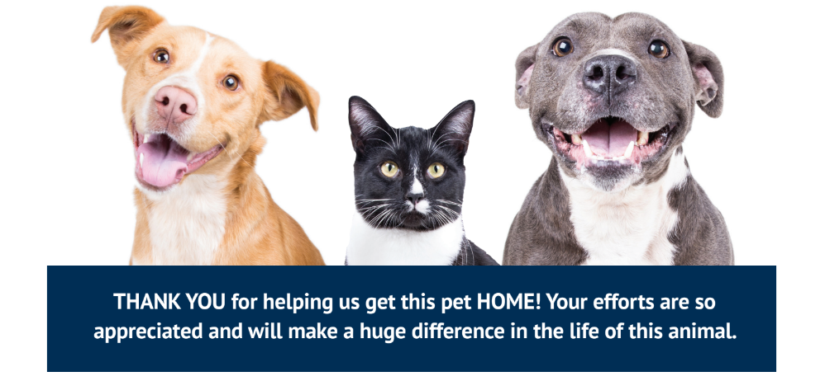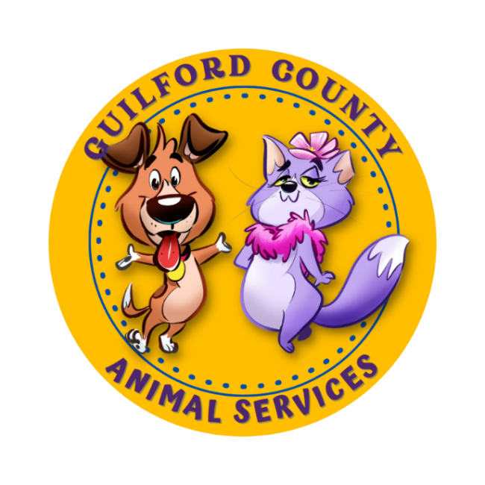Dog’s Day Out Program

**THANK YOU for gifting your time to our shelter dogs! By taking them out for just a few hours a day, our temporary residents can exert pent up energy as well as be mentally stimulated to new experiences and people! As a result of a Dog’s Day Out, our dogs are less anxious or exuberant when they meet potential adopters and they gain useful life skills that they wouldn’t get from just sitting and waiting in the shelter.**

The Dog’s Day Out program allows an approved member of the public to come and pick up a dog that meets the requirements for the program and take them off the property. The program operates during staff hours: **Monday-Sunday from 8 AM to 4:30 PM**.

**Program Overview**

**Volunteer Qualifications**

•Volunteer must be 18 years or older and a valid NC driver’s license

•Have an approved Dog’s Day Out or volunteer application on file

•Agreed to and signed the Dog’s Day Out Contract terms and conditions

**Qualifications For the Dog**

• The dog taken out must be spayed/neutered, over the age of four (4) months old, not have any special behavioral or medical restrictions, or had surgery in the last 5 days.

**Guidelines**

• Have the dog under YOUR supervision at all times.

• Never leave children unattended with any dog. DO NOT let children hug the dog or get in the dog’s face.

• Inform us if the dog bites anyone (you included) right away.

• Keep the dog on leash unless confined in your home/back yard. Retractable leashes are not allowed.

• **Personal pets are not allowed to interact with the GCAS dog. No dog or cat testing.** This time is for the shelter animal.

• Do not take the dog to off-leash dog areas or dog parks.

• Pick up and return the dog at the agreed upon times (Anytime between 8AM-4:30PM).

• Transport the dog in a safe manner by either having them in a crate or safely restrained in a

back seat.

• Report any behavior or medical concerns to your coordinator.

• If the dog picked is heartworm positive, they can only be walked and not allowed to do high energy activities.

• Keep the dog safe by providing adequate rest, shade, shelter and water.

• Utilize only positive reinforcement training (do not verbally or physically punish the dog).

• Have a cell phone with you so that you can be contacted at all times.

• Present the dog in a positive way to potential adopters and members of the public.

• The dog should be wearing an “Adopt Me” vest or bandana when out in public (the Foster and Volunteer Coordinator will have those available).

• Please wear closed toed shoes.

**Know Before You Go**

**Before You Pick Up Your Dog**

Be prepared for anything. Remember, we don’t know what many of these dogs have been through. This includes their past, how they have been treated, what their living situation once was, and most importantly, we don’t know their true personality. We gather as much information as we can from what we see here at our facility and what little (if any) information their previous caretaker provided. We try our very best to match you with a dog you are comfortable with, but please note that a dog may have a very different personality once they exit the shelter.

Ready your car with the appropriate amount of space for the dog and a size-appropriate crate. If you plan to take your dog home, please check your fence line and property for holes, loose planks, poisonous plants, foxtails, and dangerous household items.

*Guilford County Animal Services will provide you with:*

• Leash • Collar/Harness • Crate • Poop bags • Water bottle/bowl • “Adopt Me” gear •Treats

**What if my dog gets loose/escapes?**

Try not to panic. If you can see the dog, try calling them or throwing some treats in their direction. The “smellier” the treats, the better. If you have someone with you and are close to home, ask them to go get hotdogs, deli meat, or anything “high value” that is safe for dogs to eat to help lure the dog to you. Some of our more social guests may come right to you, but very often even social dogs get frightened once they get loose. You may be more successful calling them to get their attention and then walking the opposite direction, kneeling down and digging in the dirt like you've just found something extremely interesting. Reaching for a scared dog will often cause them to bolt and can also result in a bite, so please use caution and only reach for the dog if you feel you can safely do so. If the dog is in an area that is secured but is so scared that they are growling at you, please call us so that we can help! If the dog is already in a flat out run and is panicked, they may not respond to you at all. Please try following them from a distance so that you can see the direction they are going and hopefully catch up to them once they have slowed down. If they enter a yard, garage, etc., please secure the area to make sure they can't bolt again before attempting to lure them to you. We understand that every circumstance is different and that luring your dog to you may not be possible, please call us if this is the case!

**Dog Bites**

If the dog bites anyone (you included) we need to know right away. If the dog bites a

stranger, please take all of their information so that we can contact them to fill out the

appropriate paperwork. We will need you to document what happened, the location and

severity of the wound. We are required by law to report any bites that break skin to Animal Control and must follow state laws for quarantine. A bite is not an automatic reason for euthanasia, so please do not hesitate to report it. If you are seeing any signs of aggression, even if it is minor, please contact the shelter immediately.

**What if someone is interested in adopting?**

If you encounter someone who is interested in adopting your dog, please notify the Foster Coordinator and get the person’s name and number if the person is not able to adopt the dog the same day. If they are ready to take the dog home, you can bring the interested party to the shelter and the front desk staff will assist with the adoption process.

**Ideas for a Dog’s Day Out**

• A walk through the park

• Coffee at a dog-friendly café

• A shopping trip to dog-friendly stores

• Spa Day at a local groomer

• Snuggling and a movie at home

• Walking or hiking trails

• Swimming at safe, dog-friendly locations

• Brewery hopping

**Important Phone Numbers and Contacts**

**GCAS**

(336) 641-3400

980 Guilford College Rd

Greensboro, NC 27409

**Foster Coordinator**

**Stephani Crandall**

(336) 937-1867

[scrandall@guilfordcountync.gov](mailto:scrandall@guilfordcountync.gov)

**(Go here first) Happy Tails Emergency Veterinary Clinic**

(336) 288-2688

2936 Battleground Ave

Greensboro, NC 27408

**Carolina Veterinary Specialists**

(336) 632-0605

501 Nicholas Rd

Greensboro, NC 27409

**For Animal Control emergencies, questions or comments, call (336) 641-5990.**

If you are unable to reach the Foster or Volunteer Coordinator and the situation is urgent, please contact Animal Control Dispatch (336-641-5990). If Dispatch is unavailable, you can try calling Metro 911 non-emergency number (336-373-2222). For true emergencies, call 911.

**Apply /Document Your Day!**

We love to see and hear about your adventures! Taking pictures of your day can help these pups find an awesome forever home. Many of our adoptions occur as a result of the dogs being seen on our website. It is very important that we have adorable photos, and if possible, a great video of your dog. We need your help to make sure your dog is seen as much as possible!

If you post pictures on social media, please tag us in the following groups:

Guilford County Animal Services

Guilford County Animal Services Volunteers

Guilford County Animal Services Fosters

@guilfordcountyanimalservices

Use the hashtags: #dogsdayout #GCAS

You can also email photos to the Foster Coordinator.

Woo-Hoo! Doggy Day Out! Thank you for participating!